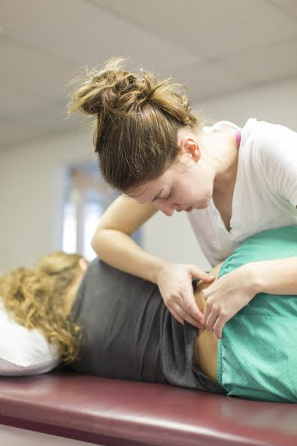
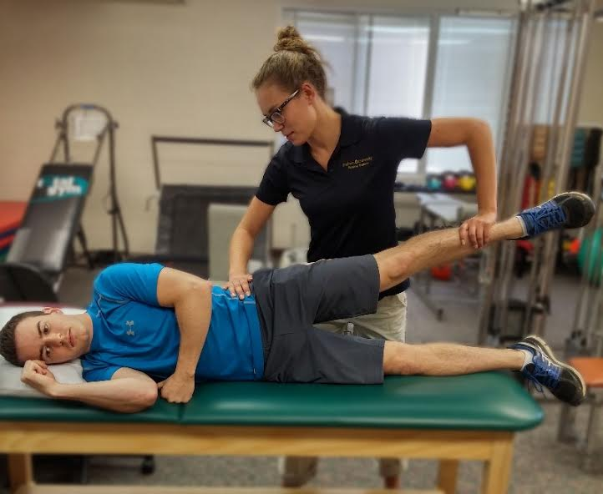
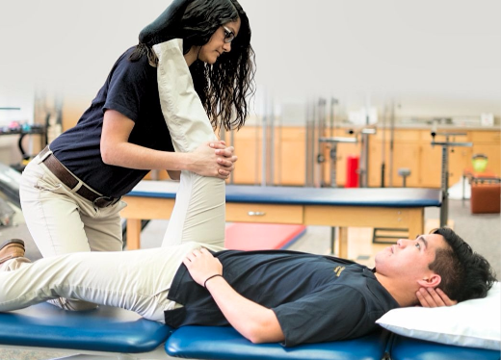
  - Email ptserviceclinic@gmail.com to schedule your appointment
10am-5pm
All ages and all physical injuries can get a FREE examination by student physical therapists along with supervising licensed physical therapists. Appointments are encouraged due to limited walk in availability.
8515 East Campus Circle Drive Berrien Springs, MI 49103

PHYSICAL THERAPY SERVICE CLINIC

Andrews University Dept. of Physical Therapy

Sunday November 4th, 2018

