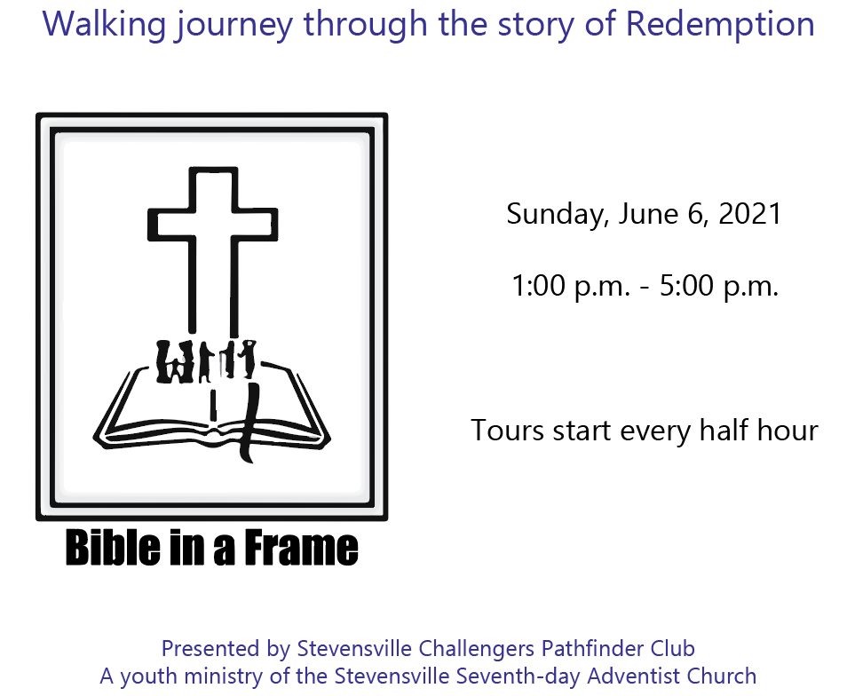
6657 Stevensville-Baroda Road
Stevensville Michigan

